Terrafom task 2

Create 2 EC2 instances on 2 different regions

Terraform apply:

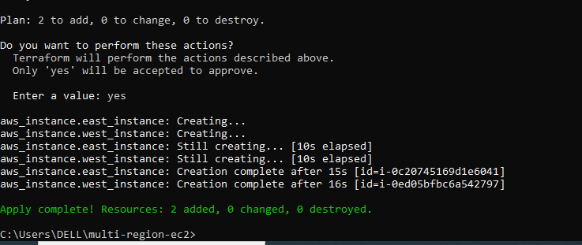

Instance triggered:

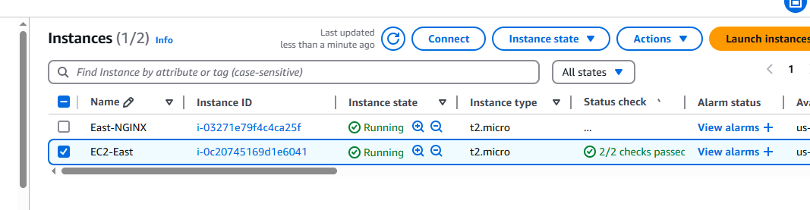

and install nginx using terraform script.

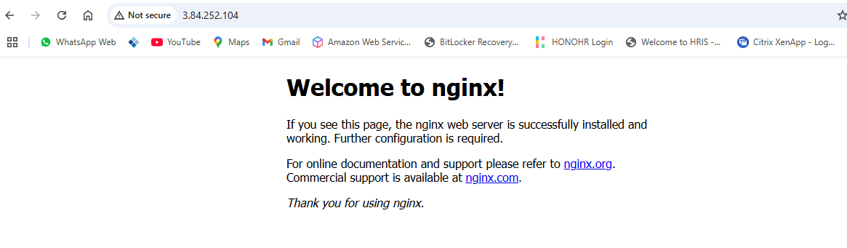

Main.tf file:

